Longevity Noodles

* [Nutrition](http://www.teambeachbody.com/teambeachbodyblog/category/nutrition)

* [Recipes](http://www.teambeachbody.com/teambeachbodyblog/category/nutrition/recipes)

2 days ago

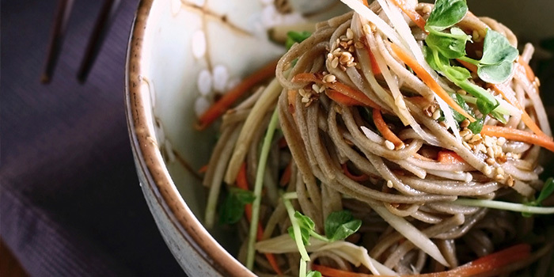

This dish is often served during Chinese New Year because it symbolizes long life. We think that is a good reason to eat it more often!

**Total Time:** 25 min.  
**Prep Time:** 15 min.  
**Cooking Time:** 10 min.  
**Yield:** 6 servings, 1½ cups each

**Ingredients:**  
6 oz. dry rice noodles (or whole-grain angel hair pasta)  
1 Tbsp. sesame oil  
1 medium carrot, cut into matchstick-sized pieces (or 2/3 cup shredded)  
2 medium shallots, finely chopped  
2 cloves garlic, finely chopped  
2 cups low-sodium organic vegetable broth, warm, divided use  
3 Tbsp. reduced-sodium soy sauce  
6 oz. cooked chicken breast, boneless, skinless, shredded  
2 cups thinly sliced Napa cabbage  
½ cup bean sprouts (mung beans)  
2 green onions, thinly sliced (for garnish; optional)

**Preparation:**  
1. Cook noodles according to package directions. Set aside.  
2. Heat oil in large skillet over medium heat.  
3. Add carrot and shallots; cook, stirring frequently, for 3 to 4 minutes.  
4. Add garlic; cook, stirring frequently, for 1 minute.  
5. Add ½ cup broth, soy sauce, chicken, cabbage, and bean sprouts; cook, stirring constantly, for 3 to 4 minutes, or until cabbage is tender-crisp. Set aside.  
6. Divide noodles evenly between 4 serving bowls. Top evenly with remaining broth, carrot mixture, and green onions (if desired).  
7. Serve immediately.

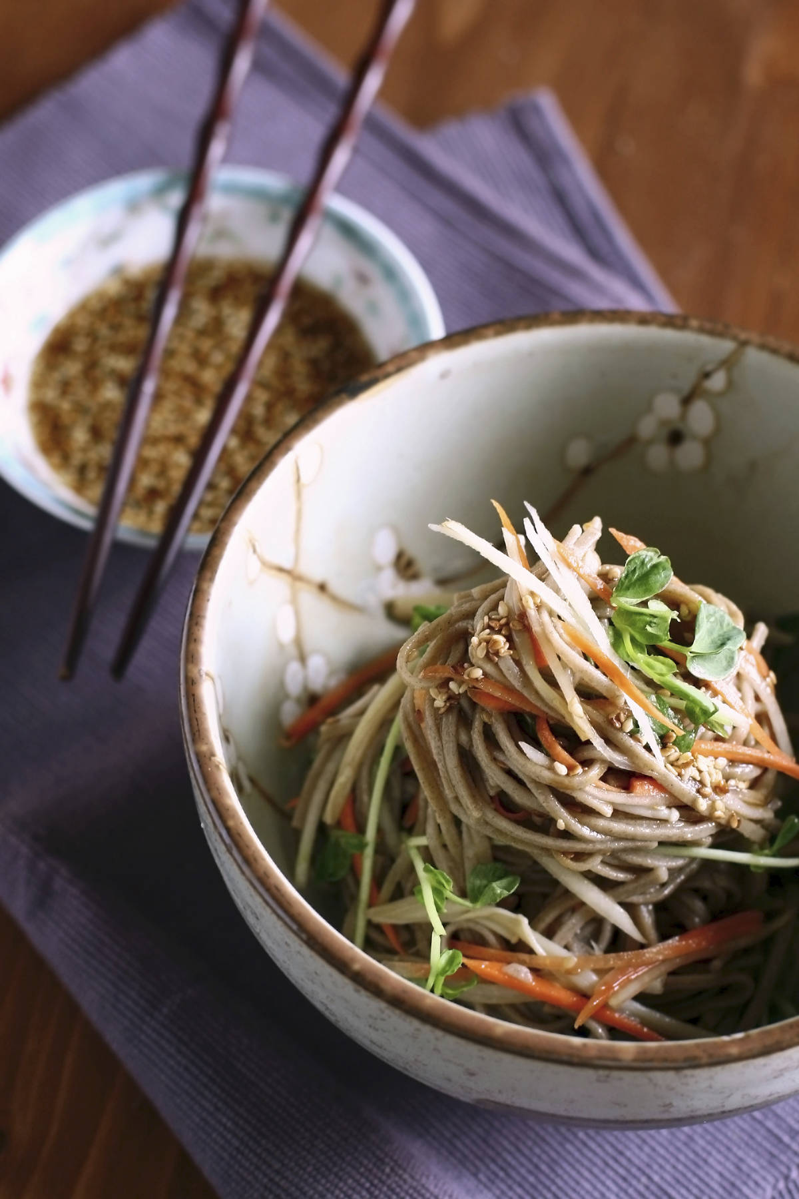

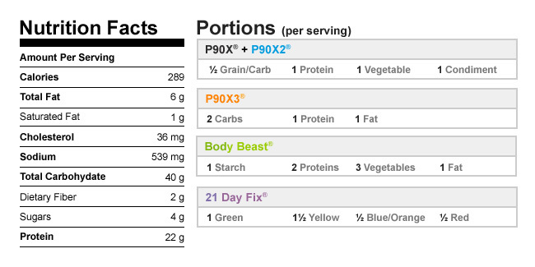

Authors

[Beachbody](http://www.teambeachbody.com/teambeachbodyblog/author/beachbody)

Tags[chicken](http://www.teambeachbody.com/teambeachbodyblog/tag/chicken), [dinners](http://www.teambeachbody.com/teambeachbodyblog/tag/dinners),[lunches](http://www.teambeachbody.com/teambeachbodyblog/tag/lunches), [pastas](http://www.teambeachbody.com/teambeachbodyblog/tag/pastas), [recipes](http://www.teambeachbody.com/teambeachbodyblog/tag/recipe)

RELATED POSTS